**Group 6 2ECE-B**

**REYES, John Emmanuel ECE 2112  
ZABALA, Jude Nico**

**MACHINE PROBLEM 1**

**CODE:**

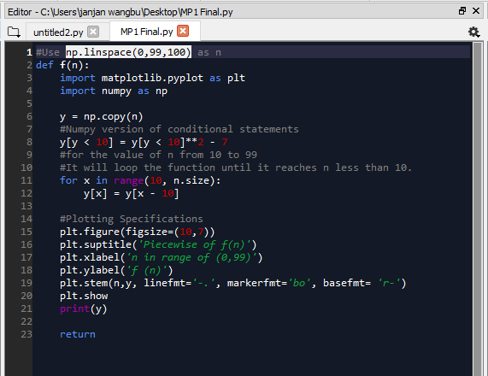

**SAMPLE OUTPUT:**

**(output of f(n) is included for checking purpose( print () not in actual program).**

**VALUES OF f(n): ; n=0:99**

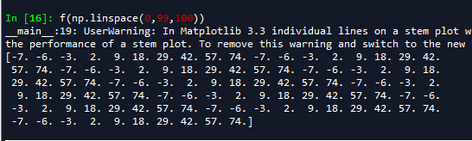

**GRAPH**

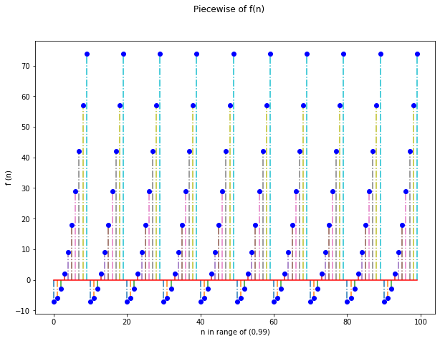

The stem plot shows the value of f(n) from n=0 to n=99. The value that exceeds 10 and above repeats the function f(n-10) until it reaches to the point where n is less than 10, thus showing a similar repeated stem plot in n=1 to n=9 range, to the whole n.